- 10 APRIL 2018

UK survey reveals widespread sexual misconduct by academic staff
F﻿our in ten respondents to a national survey said they had been sexually harassed by staff, but few students reported the incidents.

Nisha Gaind
A major survey of current and former UK students has found that 41% experienced sexual misconduct — such as inappropriate comments, unwanted touching or assault — by staff at university. Postgraduate students were more likely than undergraduates to report experiencing harassment, and most perpetrators were identified as academic rather than other university staff members.
Nearly 1,840 students across education stages and genders answered the poll, the first national UK study of staff-to-student harassment. About 12% of the 1,535 respondents who are current students said that a staff member had touched them in a way that made them uncomfortable.
But fewer than 1 in 10 respondents who said they’d experienced sexual misconduct reported it to their institution. For universities, the data suggest widespread failures in processes around harassment, says Anna Bull, a sociologist at the University of Portsmouth, UK, who worked on the survey. “There is some evidence that universities are making up investigation and complaint processes as they go along,” says Bull.
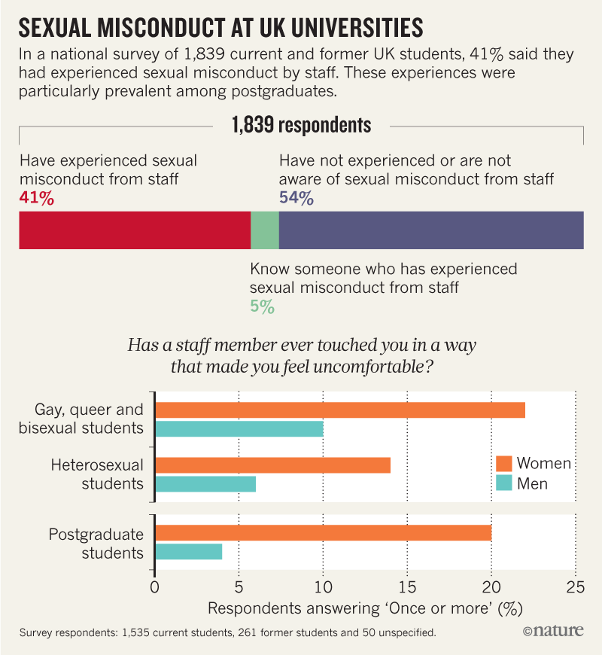
The survey was carried out in November 2017 by Britain’s National Union of Students (NUS), together with the 1752 Group, a lobby organization that aims to end sexual harassment in higher education. In their report, the groups use the term ‘sexual misconduct’ to mean a “continuum of sexualised and predatory behaviours”, emphasizing that the concept of misconduct addresses the “﻿power imbalance between staff and students in higher education”.
In 2016, Universities UK — an umbrella association for British universities — recommended strategies for institutions to deal with harassment. A review released by the organization on 28 March found that universities had made some progress — although at varying rates.﻿ “But there is more work to be done, particularly in relation to tackling staff to student sexual misconduct,” a Universities UK spokesperson said in response to the NUS survey. The Universities UK review suggests “active senior leadership” is crucial for change.
Stark split
The NUS report found that 16% of women reported unwanted touching by a staff member, as did 7% of men (see ‘Sexual misconduct at UK universities’). “We suspected from our activism and case work in this area that women are more affected by sexual misconduct, but we were surprised by the difference,” says Bull, who is part of the 1752 Group. The results have implications for gender equality and for ensuring equal access to education for all groups, she says.
Women were also three to four times more likely than men to report changing their behaviour as a result of the misconduct they experienced — for example, by skipping lectures or tutorials. Students who identified as gay, queer or bisexual were found to be at an overall higher risk of staff sexual misconduct; 23% of women in this group said that they had experienced unwanted touching by staff. Postgraduate students were overall more likely to report sexual misconduct than undergraduates: for instance, 15% of postgraduates and 6% of undergraduates said a staff member had attempted to draw them into a discussion about sex.
“Sadly, I am not surprised by the findings of this report,” says Erika Marín-Spiotta, a biogeochemist at the University of Wisconsin–Madison who is leading a US$1.1-million US initiative to develop strategies to address sexual harassment in science settings. But data are key for identifying the problem and finding solutions, she says, and the information about behavioural changes in response to harassment is crucial to understanding the impact sexual misconduct has on people, their communities and to society overall. “No one wants to believe this is a problem in their own discipline or institution until there is data showing otherwise.”
Global concern
The UK report follows a 2017 national survey in Australia of some 30,000 undergraduate and postgraduate students, 21% of whom reported experiencing sexual harassment. And a 2015 study by the Association of American Universities — designed to assess the prevalence and characteristics of harassment — found that 48% of students across education stages reported experiencing sexual harassment.
The UK survey should not be considered representative of the wider UK student population, say the authors: they made an extra effort to sample more postgraduate students because previous research has shown that the group is more affected by sexual misconduct than undergraduates. However, the authors also gathered focus groups of students to discuss conceptions of professional boundaries between staff and students, with a particular focus on groups who are more likely to be affected by sexual misconduct, including postgraduate students, black students and students from sexual and gender minorities. “There is still surprisingly very little data on how sexual misconduct is experienced by people with different racial, ethnic and gender identities, or people with disabilities,” says Marín-Spiotta.
The groups who conducted the survey hope that their work will spur a larger study on the prevalence of sexual harassment at UK universities, says Bull. In the meantime, disciplinary policies need urgent overhaul, and all universities should have robust policies on staff-to-student relationships, she says. “At the moment, many universities do not have good enough policies and procedures to start encouraging students to report misconduct,” says Bull.
doi: 10.1038/d41586-018-04212-2
https://www.nature.com/articles/d41586-018-04212-2

